**AIOPS Assignment 4**

1. **What is Docker, and why is Docker used?**

Docker is a platform that enables developers to automate the deployment, scaling, and management of applications using containerization technology. Containers are lightweight and portable units that encapsulate software and its dependencies, including libraries, system tools, runtime, and code, into a single package. Docker provides a consistent environment for running applications across different computing environments, such as development, testing, and production.

Here's why Docker is used:

**Isolation and Consistency:** Containers provide isolation between applications and their dependencies, ensuring that they run consistently regardless of the underlying infrastructure. This eliminates the "it works on my machine" problem and simplifies the deployment process.

**Portability:** Docker containers are designed to be portable, which means that an application packaged as a Docker container can run on any system that supports Docker, whether it's a developer's laptop, a testing server, or a production cluster.

**Efficiency:** Docker containers share the host operating system's kernel, which reduces overhead compared to traditional virtualization. This allows for greater efficiency in terms of resource utilization and faster startup times.

**Version Control:** Docker allows you to version control your application's entire environment, including its code, libraries, and configurations. This ensures that the exact same environment is used for development, testing, and production.

**Scalability:** Docker containers can be easily scaled up or down depending on the demand. This is particularly useful for applications that need to handle varying levels of traffic.

**Microservices:** Docker facilitates the microservices architectural pattern, where an application is broken down into smaller, loosely-coupled services. Each service can be containerized, making it easier to develop, deploy, and scale individual components independently.

**Continuous Integration and Continuous Deployment (CI/CD):** Docker simplifies the CI/CD process by providing a consistent environment for building, testing, and deploying applications. This helps streamline development workflows and ensure reliable deployments.

**Ecosystem:** Docker has a rich ecosystem of tools and services that enhance various aspects of the development and deployment lifecycle, such as Docker Compose for orchestrating multi-container applications, Docker Swarm for container orchestration, and Kubernetes for managing containerized applications at scale.

**Resource Isolation:** Docker uses resource isolation features of the Linux kernel to allocate specific resources, such as CPU, memory, disk I/O, and network bandwidth, to each container. This helps prevent applications from interfering with each other and ensures stable performance.

1. **Explain the Docker architecture?**

The Docker architecture consists of several components that work together to enable containerization, deployment, and management of applications. The architecture is designed to provide a flexible and scalable environment for running and orchestrating containers. Here's an overview of the key components in the Docker architecture:

**Docker Daemon (dockerd):** The Docker daemon is a background process that manages Docker containers on a host system. It's responsible for building, running, and monitoring containers. It communicates with the Docker client and handles container lifecycle operations such as starting, stopping, and managing containers. The daemon listens for API requests and interacts with the underlying host's operating system to manage container resources.

**Docker Client:** The Docker client is a command-line tool that allows users to interact with the Docker daemon. Users can issue commands to the client to build, run, stop, and manage containers, as well as manage images, networks, and volumes. The client communicates with the Docker daemon over the Docker API, which can be accessed either locally or remotely.

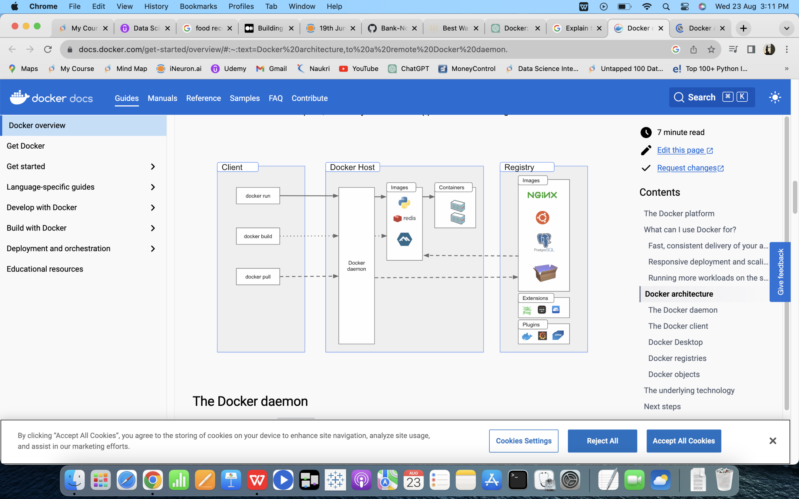

**Docker Images:** A Docker image is a read-only template that contains an application, its dependencies, and configurations required to run the application. Images are created from a set of instructions defined in a Dockerfile. Images are stored in a registry (like Docker Hub or private registries) and can be versioned, shared, and reused across different environments.

**Docker Containers:** A Docker container is an instance of an image. Containers are lightweight and isolated runtime environments that encapsulate the application and its dependencies. They share the host system's kernel but have their own filesystem, process space, network, and resources. Containers can be created, started, stopped, and deleted using the Docker client.

**Docker Registry:** A Docker registry is a repository for storing and distributing Docker images. Docker Hub is the default public registry, but organizations can set up their private registries for security, compliance, and performance reasons. Docker images are pushed to and pulled from registries. This allows for easy sharing and distribution of images across different environments and teams.

**Docker Compose:** Docker Compose is a tool for defining and running multi-container applications. It uses a YAML file to define services, networks, and volumes required for an application. Compose simplifies the process of managing complex applications that consist of multiple interconnected containers, allowing them to be managed and orchestrated together.

**Docker Swarm and Kubernetes (Optional):** Docker Swarm and Kubernetes are orchestration tools used to manage and scale containerized applications in a clustered environment. They provide features for load balancing, service discovery, automated scaling, and high availability. Docker Swarm is Docker's built-in orchestration solution, while Kubernetes is a more comprehensive orchestration platform that supports containerized applications from multiple sources.

1. **What do you mean by a Dockerfile?**

A Dockerfile is a text file that contains a set of instructions for building a Docker image. It defines the base image, along with the necessary steps to install, configure, and set up the application and its dependencies within the image. Docker uses these instructions to automate the process of creating a reproducible and self-contained image that can be used to run containers.

Dockerfile Instructions: Some common Dockerfile instructions include:

FROM: Specifies the base image.

RUN: Executes commands inside the container during the build process, such as installing software.

COPY and ADD: Copies files from the host into the image.

WORKDIR: Sets the working directory for subsequent instructions.

ENV: Sets environment variables.

EXPOSE: Specifies which ports the container should listen on.

CMD or ENTRYPOINT: Defines the command to run when the container starts.

1. **What do you mean by Docker Images?**

Docker images are the building blocks of containerized applications. They encapsulate an application, its runtime, and its dependencies into a single, self-contained unit, enabling developers to create, distribute, and deploy applications consistently across different environments.

1. **What do you mean by Docker Hub?**

Docker Hub is a cloud-based registry service provided by Docker that serves as a central repository for storing, sharing, and distributing Docker images. It's a platform that allows developers to publish their Docker images and share them with others, as well as discover and use images created by the broader community. Docker Hub is commonly used for both public and private image hosting.

1. **Which command can be used to check Docker Client and Docker Server Version?**

To check the version of the Docker client and Docker server, you can use the following command:

docker version

Running this command in your terminal will provide information about both the client and server components of Docker, including version numbers, build information, and more. The output will be divided into "Client" and "Server" sections, indicating the respective versions of each component. This command is useful for verifying the versions installed on your system and ensuring compatibility between the Docker client and server.

**7. How to create a Docker container from an Image?**

To create a Docker container from an image, you'll use the docker run command. This command pulls the image (if not already available locally) and starts a new container based on that image.

Here's the basic syntax:

docker run [options] image_name [command]

Let's break down the components:

[options]: Various options that you can use to customize container behavior, networking, and more.

image_name: The name of the Docker image you want to create a container from.

[command]: An optional command that you want the container to run when it starts. If not specified, the default command from the image's Dockerfile will be used.